Use-Case Realization Report(Design)
Add Page

Issue <1.0>
Revision History
Date | Issue | Description | Author
29/11/09 | 1.0 | Initial Version | Rajendran Kumaraguru

Table of Contents
1. Brief Description 4
2. Flow of Events 4
3. Interaction Diagrams 4
3.1 Collaboration Diagram for Add Page 4
3.2 Sequence Diagram for Add Page 5
4. Participating Objects 5
5. Class Diagrams 6
5.1 Class Diagram for Add Page 6
6. Derived Requirements 6

Use-Case Realization Report (Design)
Add Page

Brief Description
Upon creation of site creation and outline creation, portal admin will be performing the page creation in order to upload the content.

Flow of Events
- Portal Admin log into the system, and go to Page Admin Page.
- By clicking the “btnAdd_Click” button, the Page maintenance screen will be invoked in order to create the page and its content for the created outline and site.
- Page sorting will be invoked in order to have customized sorting.
- Field values for the creation of the page will be validated.
- While creating the page the tree view will be created.
- Save page will be invoked in order to save the page.
- Module will be saved together with page save.
- Upon successful creation of the page and module then success message will be displayed to the portal admin.

Exception Flow
If there is any validation error while validating the fields the exception message will be thrown to portal admin.

Interaction Diagrams

Sequence Diagram for Add Page
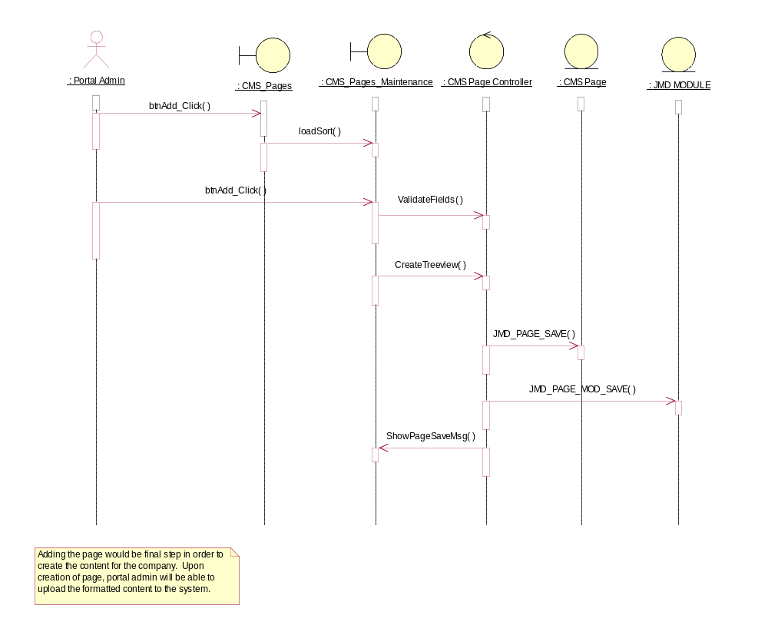

Participating Objects
: CMS Page

: CMS Page Controller

: CMS_Pages

: CMS_Pages_Maintenance

: JMD MODULE

: Portal Admin

Class Diagrams

Class Diagram for Add Page
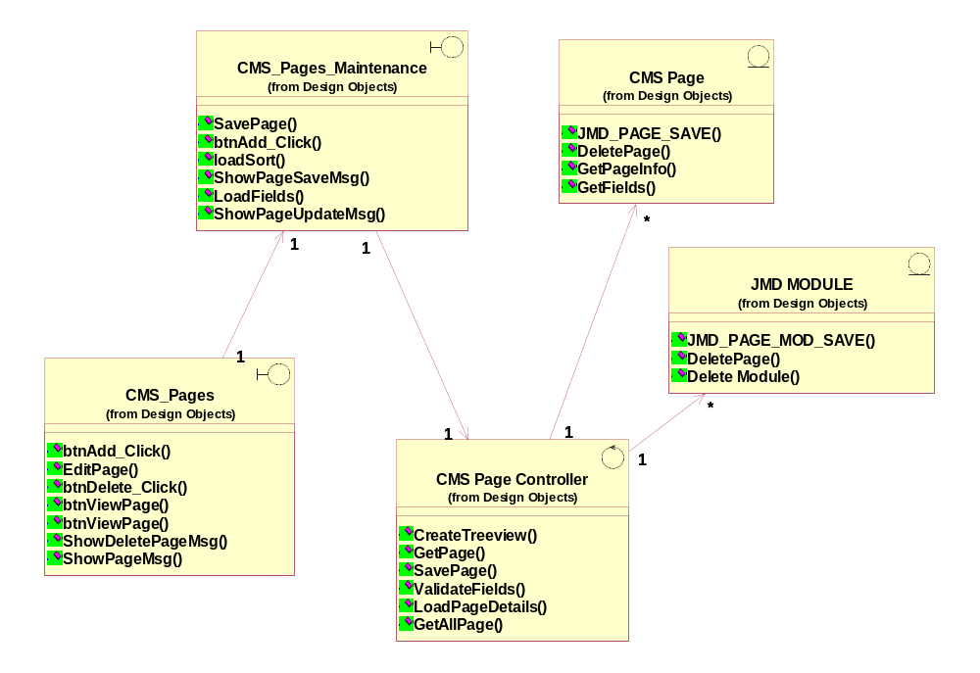

Derived Requirements
[enter the derived requirements here]

